**PHINMA UPANG COLLEGE URDANETA**

**Nancayasan, Urdaneta City**

**ACCOUNTING BUSINESS MANAGEMENT**

**12 ABM 4**

MARKETING PLAN

Presented as Partial Fulfillment of the Requirement for

**ABM 006: Principles of Marketing**

Submitted to:

**ARNEL Z. BAUZON, MBA**

**Professor**

Submitted by:

**AGASA, MICAH A. CARIÑO, DEAVIN JOHN F.**

**ALEGADO, LOUILYN P. CASTRO, EUNICE R.**

**AQUINO, NATHALIE GRACE V. CORPUZ, JESSICA MAE E.**

**ARANIEGO, SARAH MAE T. CRUZ, ARCY JOY M.**

**ARMEA, CHYNNA RYCEL G. DILAN, SHAIRA MAE V.**

**BERNATE, AIDREEN O. EDEP, ALNIL BREGIT T.**

**CAMAGAY, JANINE CLAIRE B.**

ABM STUDENTS

Academic Year 2021-2022

First Semester

ACKNOWLEDGEMENT

*The researcher would like to acknowledge unfeigned gratitude and profound appreciation for the consecutive people who, nevertheless, shared their utmost personal professional assistance and vigorous service that made this book report an incomparable reality.*

*Above all, to the LORD ALMIGHTY, for giving the researcher patience when he/she is about to give up. Strength and wisdom which kept him/her going and moving forward, and love that filled his/her passion which made him/her hold.*

*Mr. Arnel Z. Bauzon, faculty member of Graduate School and adviser in this book report who kindly and patiently lent a hand to the researchers, with his unfailing effort in guiding us and for giving us encouragement long before the making of this book report. Undeniably, we learned tremendously from him.*

*Co-researcher, for the valuable efforts he/she complete this book report,*

*ABM Classmates, for sharing ideas to the researcher on how to make a good book report.*

*To everyone, thank you so much.*

*Group 7 Marketers-*

TABLE OF CONTENTS

PAGE

COVER PAGE i

ACKNOWLEDGMENTS ii

TABLE OF CONTENTS iii

Executive Summary 1

Product and Services 2

Mission and Vision 2

Logo 3

Tagline 4

Marketing Materials 5

Customer 6

Competitors: Market Positioning 7

Competitor Analysis 8

SWOT Analysis 9

Product Versus Top Competitor 10

PESTEL Analysis 11

STDP Marketing 12

Product Positioning 13

Marketing Objectives 14

Marketing Mix 15

Executive Summary

Since then we Filipinos usually has dessert that is served right after lunch or dinner . We Filipinos often called dessert as “ Merienda “ and Merienda is a light-meal or snack that can either be savory or sweet and we also known as having a sweet tooth in every occasion, something sweet must always be on the table , and here in province puto is well known as one of the dessert , but not because it was delicious but also this represent our culture and one of the valuable delicacies that represent the whole Pangasinan , it also has other variant , puto is originated here in Philippines, it is made by slowly adding water to ground rice until the correct texture is achieved, also the use of hot water would improve the softness,the original flavor of puto was puto Calasiao and that's how our product emanated which is the “Puto Moschata “. We add new flavors the squash and yema filling. Since our customer was Filipinos and we know that Filipinos loves to try new foods and flavors that helps them to eat healthier, and introduce them to different cultures. Also it adds a new level of excitement for our customers.

Yema is a sweet custard confectionary from the Philippines. It is made with egg yolks, milk, and sugar, the name yema is from Spanish for "egg yolk". Like other egg yolk-based Filipino desserts, it is believed that yema originated from early Spanish construction materials. During the Spanish colonization of the Philippines, egg whites mixed with quicklime and eggshell were used as a type of mortar to hold stone walls together. Filipinos reused the discarded egg yolks into various dishes , among them is yema which is possibly based on the Spanish pastry “Yemas de Santa Teresa”.

**Product and Services**

Fluffy, shiny and smooth on top - Has a cake-like texture - Soft, moist and has uniform grain. - It should be neither sticky nor dry and crumbly. Mashed Squash, Cup Cake Flour, Fresh milk, Sugar, Eggs, Butter, Vanilla essence, and Yema are the components of our product. Its texture is Soft, moist, and with a fine, uniform grain.

Squash was chosen as the major ingredient since it is abundant in our locality and contains numerous nutrients such as Carbohydrate, Protein, Dietary fiber, Sodium, Niacin, Potassium, Carotenoids, Calcium, Vitamin A, Vitamin C, Vitamin K, and Zinc. All of these elements combine to make it a very nutritious and complete food that assists you in obtaining all of the necessary nutrients for your body.

Mission and Vision

Mission

Our business is existing because Business is for everyone business plays a big part in our industry. The existence of our business is important because it has a big role in our country it encompasses all those who are involved in growing, processing, manufacturing or distributing food from the farm to retail shops and restaurants.

This article focuses on manufacturers of packaged food products, so we came up to the idea to sell our own “Puto” (rice cake).

We decided to be part in food industry business because food is our primary need, we can resist from buying our wants but it will be hard to resist hunger. That's why we decided to have a product 'Puto' because food is one of the most profitable business in the world. There is a lot of opportunities in food industry example delivery services and cafes because, the demand for food business is so high, the market has become extremely competitive.

Vision

We want our business to serve more happiness and healthier product but affordable. We want our Company to be one of the most popular when it comes to the product “Puto” not just here in Philippines but all over the world.

**Logo**

We've designed this as our logo to present our product. The woman in the picture symbolizes us, (The baker) and when you look at the picture the woman in the picture was baking which represents on how we do our main ingredient. Our product name that is form circle stand for our fully baked product shape along the background color that symbolize the color of Yema, our main toppings and the other design are formed to attract the customers.

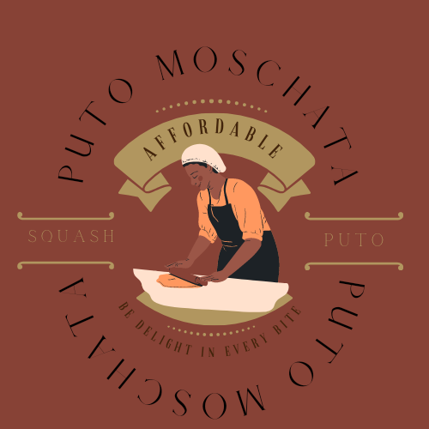

Tagline

Our tagline “Be delight in every bite” which means our product is affordable and delicious that you can choose anytime. It encourages our customers to buy our product, because it can give them satisfaction and pleasure and also because of the sweetness of our product that is moderate and provides vitamins and nutrients that all of us need. Based on the tagline, it really means that our product is delightful and healthy that is meticulously picked for our customers.

Once they read our tagline, they would definitely think that our product is the best choice and have the best taste that they would never forget and this tagline will surely be an unforgettable tagline to our customers or target markets.

Marketing Materials

Flyer

Flyer are one of the most versatile, effective as well as affordable marketing tools. Having a business flyer will help us to promote our product easily since a lot of people will see it in different places for it is handed directly to them. They will have a prior information about what they will expect in our product. It is such an affordable way to promote.

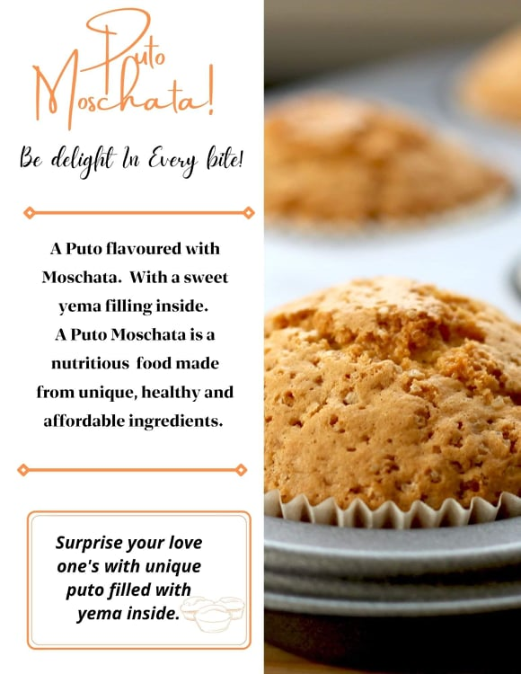

**Tarpaulin**

We use Tarpaulin because it's sturdy and weather proof. Tarpaulins can be posted for a longer period of time, they can last for months and even for years. It is also an efficient way to promote our product and it's also recognizable that can be easily capture the customers.

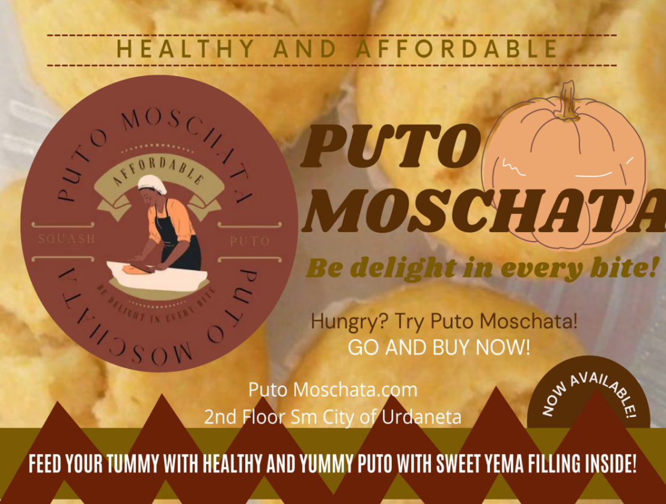

**Business Card**

Business Card is one of the most effective tool and affordable way to promote our product. It is easy to distribute just like a flyer. It can also act as a static display, where people can pick them up as they pass by.

It can also help to make a powerful impression on clients. Business cards are really an extension of our brand or product.

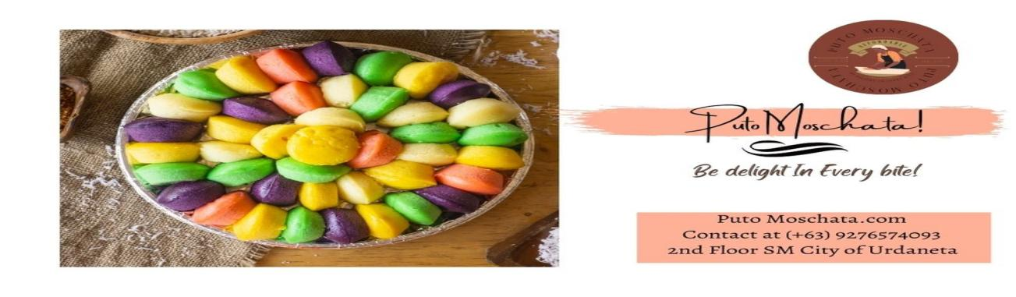

**Mug**

Mugs is one of the most popular promotional products. So we decide to make this as a Marketing Material because, every time they use this Mug to drink a hot or cold beverage they will always see and remember our Product.

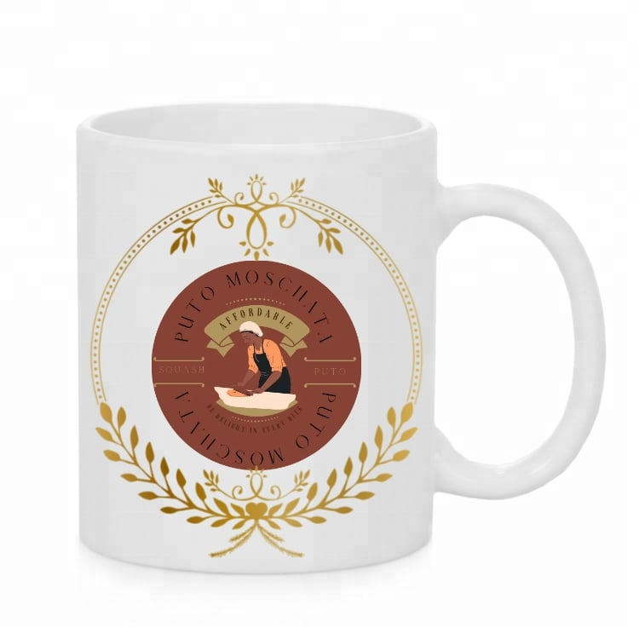

**Plate**

This Plate is also our Marketing Material. We also decided to make a Plate because our Product is food. The customers will remember our product when they use the Plate. The Plate will be also the partner of Mug. They can use them often because both of them are less likely to throw it away.

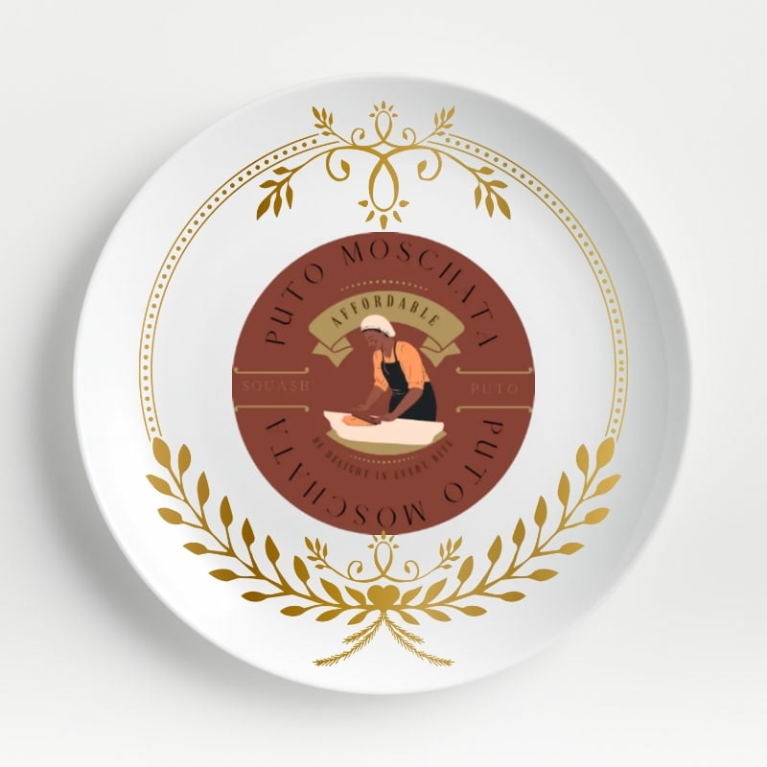

**Poster**

Posters are one of the most cost effective forms of advertising on the market. Posters allow you to spread your message to a wide audience far cheaper than radio, print or television advertising in a simple, easy and affordable way.

Also a smart way to get additional exposure for your company's brand. Posters are very beneficial because you can put them in many different places.

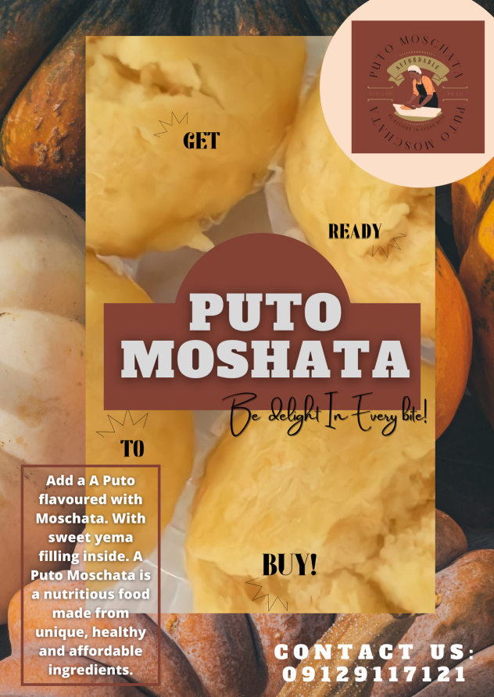

**Customer**

Puto Moschata has extensive range of customers they varies in different ages, races and gender.

Some of them are the following:

1. Health concerns - People who want a lot of nutrients and people who are on a diet.
2. The Regulars - The customer/s who comes to you when there is a celebration.
3. Measuring personality - the personality of customers who is perfectionist in the textures, characteristics, etc.. of the product.
4. People who can afford.

|  |  |
| --- | --- |
| KIND OF CUSTOMER | Why they purchased Puto Moschata |
| 1. **Health concerns - People who want a lot of nutrients and people who are on a diet.** | People who want a lot of nutrients and people who are on a diet. We know that people who have health concerns are the best suits for healthy food businesses just like what we have because they are health conscious. Having a big probability to gain more health concern customers specially in this pandemic which can help them for their healthy lifestyle. |

|  |  |
| --- | --- |
| 1. **The Regulars - The customer/s who comes to you when there is a celebration.** | People who come to you when there is a celebration, occasion or party. They are the one who always buys food for their guests, especially we Filipinos who are so used to this kind of doing that whenever there are occasions or parties in our homes. |
| 1. **Measuring personality - the personality of customers who is perfectionist in the** | A person is made up of many different qualities and behavioral characteristics that make him/her distinctively itself. Perfectionist customer would help our business for our product in suggesting a texture, characteristics and any other new thing that will help to caught feelings with other customer to enjoy our product that is why we decided to have measuring personality customer. |
| 1. **People who can afford to buy our product.** | People who can be able to afford our product. Those people who have a lot or enough money to purchase our puto product. |

**Competitors**

**Marketing Positioning**

Market positioning is how you will shape the mind-set of the customers towards your product. The Baker Brothers, Manila creamery Puto Moschata and Dunkin Donut are the 4 largest bakeshop in terms of selling baked goods did a great jobs in terms of doing marketing positioning.

|  |
| --- |
| HIGH  QUALITY |

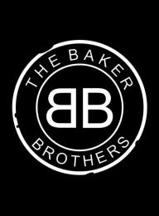  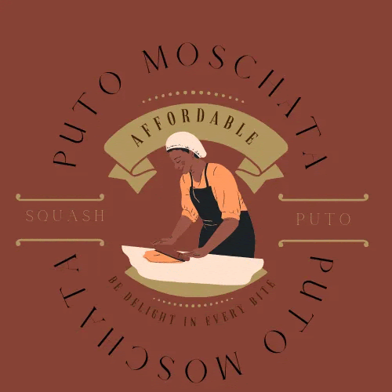

|  |
| --- |
| HIGH PRICE |

|  |
| --- |
| LOW PRICE |

|  |
| --- |
| LOW QUALITY |

The figure above tells that the four bakeshop has a high price, high quality and low price on their respective products that they offering.

|  |  |
| --- | --- |
| **PUTO MOSCHATA CONPETITOR ANALYSIS** | |
| **Competitor** | **Product They offer Versus Puto Moschata** |
| **1. Dunkin Donuts** | 240550572_894294034512378_7581557207633487884_n.jpg242177529_371695401114474_7862739125438833760_n.jpgDunkin Donuts versus Puto Moschata |

|  |
| --- |
| **PUTO MOSCHATA SWOT ANALYSIS** |
| **STRENGHTS** |
| 1. Proper Pricing   Puto Moschata is cheap because it is made with kalabasa that can find in the market or even at our backyard but it is healthy. Price is reasonable, it is fair and not too high.   1. People's need   Highly recommended because our business has a healthy product that can help consumers and customers to become healthy over this pandemic.   1. Good Listener Owner   Imparting support and understanding to the speaker which is our consumer and customer. |
| **WEAKNESSES** |
| 1. Customer’s changing Tastes   Person's taste is their choice in the things that they like or buy. Sometimes they more want sweet foods than healthy foods.   1. Less Research and Development   Customers usually get tired of the same tastes, then they would go to the other competitor.   1. Lack of cash.   Since we are starting a small business as for now we don’t have enough cash to support our business. |
| **OPPORTUNITIES** |
| 1. Implement a Loyalty Program   Having a connection with your customers allows us to anticipate their wants and needs and to deliver and satisfy them.   1. Offers Food delivery for Growth   To earn larger profits, offer some food delivery and app/technology food delivery.   1. Menu keep interesting   Company gains more customers and profits in terms of well-organized menu, it can catch their attention and will love the Product we offer and other alternatives |
| **THREATS** |
| 1. Business Competitors   Business Competitors can be a threat if their products are more unique and have cheaper price. Competitors are one of the distractions to Puto Moschata because competitors react to the strategic actions you take in the marketplace and can offer the same products and services but different goals and strategies. There is a possibility that the competitors can be the downfall of Puto Moschata.   1. Corona Virus Outbreak   The pandemic has been affecting the entire food system. Corona Virus has a negative impact to the global economy. Many businesses are affected and Puto Moschata is included. Its stores were temporary close that is why the business also stops from selling on the market. It affects the profitability of the business because the number of customers decreased.   1. Shifting Consumer Preferences and Expectations   Today’s consumers are not the same as they were two years ago. Businesses that fail to adapt to the more educated, demanding and busy consumer whose choices take precedence will be devastated. In order for Puto Moschata to survive, We have to be more versatile. This has to start with knowing what your customers want and meeting those needs. |

**DUNKIN’ DONUT**

**Dunkin’ Donut VERSUS Puto Moschata**

Dunkin' Donuts is recognized for their amazing selection of incredibly tasting donuts , it’s the world leading baked goods and coffee chain , serving more than 3 million each and every day. Thru their name they offer 50+ varieties of donuts , but you can also enjoy dozens of premium beverage , bagels , breakfast sandwiches and other baked goods . Dunkin’ provides fresh baked donuts, but their other bakery selections and meals can keep you satisfied any time of day. Their breakfast and lunch combos also come with a medium coffee or tea at no extra cost. The combo deal goes for less than the price of a Starbucks Panini, which aren’t worth the price for the pre-packed sandwich you’re getting.

Puto Moschata is a dessert that is sweet. Our product Puto Moschata is emanated to an original product "Puto Calasiao", but in our product we add a new flavor that will excite our costumer which is squash and yema filling. Puto Moschata is a fluffy, shiny, and smooth on top, has a cake texture, soft, moist and has a uniform grain. In our product the chosen main ingredient was Squash because it can give a numerous nutrients to the customers.

We all know that Dunkin Donuts is very common for us but try our new product which is Puto Moschata it's Mashed squash cup cake with vanilla essence, its texture is soft, moist, and with a fine, uniform grain.

The difference between this two products is of course first comes first is the taste, Dunkin Donuts is much sweeter than the puto yet puto is much more creamier. Second difference is the pricing, Puto Moschata is cheaper than Dunkin. All in all why not try our new delicacy Puto Moschata.

**PESTEL Analysis**

**Political Factors**

These Factors that affects the selling of Puto Moschata on the Market industry.

Political issues which needs to be considered:

Political regime's and instability

The political stability is by no means the norms in human history , democratic regime's , like all political regime's , are fraggle , irrespective of political regime's , if a country does not need to worry avoid conflicts and radical changes of regime's , saving and investing , the recent empirical literature of corruption has identified a long list of variables that correlated significantly with corruption

Freedom of press , Rule of law Bureaucracy , Corruption

Business should always strive to give abreast of any changes , opportunities and threats shaping and influencing its political environment , for example an unstable political environment in rising political political tensions in a certain regions may damage the appeal of local markets or new legislation may change the relationship between a owner and its employees and could even change the overall structure of the industry

Gross Domestic Product

The number that expresses the worth of the output of the country and local currency , gdp tries to capture all final goods and services as long as they are produced within the country thereby assuring that the final monetary value of everything that is created in the country is presented in the gdp

Disposable Income

Here's might be positive outcome when workers wage rise , this also creates more spending , an increase in consumption can increase corporate sales and corporate earnings , thus increasing the value of individual stocks . this increase in individual share price valuations could then lead to a market wide increase in a value , this has the potential to create an economic boom

The product Puto Moschata is always been embrace by it’s own Political Factors in Market Industry.

**Economic Factors**

These factors depends on how macro economic performance affects Puto Moschata:

- Inflation

The Inflation rate increases can affect to our business because the prices of the ingredients and other costs will increase. that is why in order for our business not to go bankrupt we need to raise the price of our product through this we can reduce the number of buyers of our product because at the same time, other goods will also increase and most of the people will surely avoid purchasing our product.

- Unemployment

Hiring an employee with no experience to the job assigned to him can cause problems and affect the operation of the business. you need to make sure that before you put him to that job make sure it is appropriate to their skills.

- Fiscal Policy

When fiscal policy increases, this means to promote a strong sustainable growth and reduce poverty as a result, people will have more money to spend on buying product. this will give a positive effect on the business of Puto Moschata.

**Social Factors**

Currently these days, our considerable market becomes a priority to the customer. It has a numerous market that affect both acquiring and retailing Puto Moschata. Here in Pangasinan, the Puto Moschata is popular therefore it has a loyal buyers. In other place or provinces of Luzon, other buyers also know Puto Moschata and it is emerging the popularity. Across National Capital Region, the popularity of Puto Moschata is not as good as it was approximated in other provinces of Luzon.

The entire statement adverted to quickening or change of extension in the nation and the product reach. But buyers who also wants to purchase Puto Moschata in National Capital Region cannot locate or spot the product easily considering the popularity is not good there. To give rise to service, Puto Moschata has been regaining plan of action for strategies and always maintaining with a priority for customer-oriented approach.

**Technological Factors**

Various reasons have emerged why technology is important in food production. We can't prevent the use of technology in business as the business expands.

Without technology, business owners will not be able to improve the products qualities. As well as their operations.

Moreover, technologies also contribute in business expansion. Business owners communicate to other people by using various online platforms. In terms of solving problems, it is easier to find problems.

**Environmental Factors**

Sustainable marketing is the promotion of environmental and socially responsible products, practices, and brand values. If you’ve ever spent a little bit more on something because you know it was locally sourced or 100% recyclable, you’ve experienced sustainable marketing. Starbucks tries hard to engage its community in sustainable issues. It uses green materials for producing, packaging, and delivering its product to customers. is where sustainable marketing comes in. Sustainable marketing is a way to promote products and services that meet the needs of consumers. To turn your marketing green, the right sustainable marketing strategies are crucial.

**Legal Factors**

The legal factors of Puto Moschata has good packaging, duration, expiration and health benefits. It must pass The Food and Drug Administration (FDA) of the Philippines, formerly The Bureau of Food and Drugs (BFAD). A health regulatory agency under the Department of Health.

**STDP Marketing Strategy**

Puto Moschata, the largest Bakeshop to sell and delivers goods through online and offline services. The company is known for its high brand loyalty and large customer base. Puto Moschata needs to have best marketing strategy to stay in the competition.

**Segmentation**

|  |  |  |  |
| --- | --- | --- | --- |
| Types of Segmentation | Puto Moschata | Customers | Remarks |
| Demographic - It is the most common and popular method of the segmentation. It refers to statistical data about group of people. | Puro Moschata Products. | Customers depends on the following:  - Age  - Sex  - Income  - Occupation  - Education  - Location | The Examples of Demographic are the following:   1. Mother purchased Puto Moschata. 2. A Family bought 1 bundle of Puto Moschata. |
| Psychographic - It is the more difficult to understand and it how they position their selves. | Will depend on the Customer personal basi. | Customers depends on the following:  - Lifestyle  - Personality  - Social Class  - Attitudes  - Behavior  - Interest  - Priorities | The Example of Geographic are the following:   1. Marketers who buy Puto Moschata because of its high quality 2. Barangay officials who wants to be healthy bought Puto Moschata. |
| Geographic - It is a marketing strategy used to target products or services at a particular unit, area or location. | It depends on the location | Customers depends on the following:  - Nations  - Country  - Provinces  - Cities  - Towns  - Zip code | The Example of Geographic are the following:   1. The owner of a one coffee shop purchased Puto Moschata in the Urdaneta city, Pangasinan. 2. A Lady bought Puto Moschata near her residence in the Manaoag Pangasinan. |
| Behavioral -  It focuses on the Customers action. | Based on the Customers action. | Customers depends on the following:  - Customers loyalty  -Purchasing behavior  - Spending habits  - Occasion based behavior | The Example of Geographic are the following:   1. Puto moschata offers 25% discounts to their customers that will avail worth of 100 pesos. 2. Puto Moschata offers to potential buyers a 10% discount and free delivery when they buy worth of 3 trays of the product. |

**Targeting**

In 4 types of segmentation we choose the Demographic Segmentation because Demographic refers to the description or distribution of characteristics of some target audience, customer base, or population.

It best describes on how to target the customers with our product Puto Moschata. Below are the instances when Puto Moschata used Demographic Segmentation:

* Age

Puto Moschata is suitable for people of all ages, from 7 to 60, since it is soft and easy to chew. It's a low-cost product that's also delicious. It's perfect for every occasion or simply as a snack.

* Gender

Food has no gender it applies in all product benefits and when you eat Puto Moschata, it's like your comfort meal because of its unexplainable flavour that you'll enjoy. When you're from another nation/country, it tastes like the Philippines because Puto is a Filipino delicacy.

* Income

Allows you to measure the buying power of your audience. When you know the income range of consumers, you can usually find data to support how people spend money on both the higher and lower end of the spectrum.

* Location

Based marketing aids in the removal of sales barriers. We are considerably more likely to persuade customers to buy our product if they are close to our store.

**Differentiation**

Puto Moschata is different and unique to other companies or competitors. Puto Moschata can lead to market industry because of its good , high quality and affordable price.

**Product Positioning**

HIGH QUALITY

**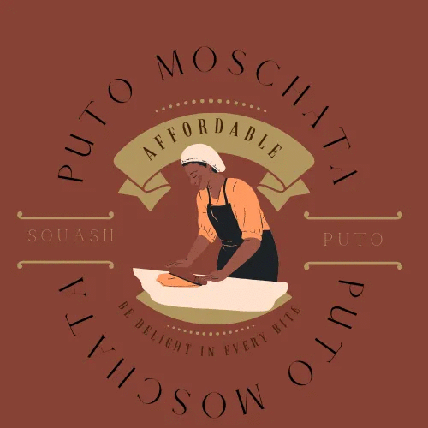**

LOW PRICE

HIGH PRICE

LOW QUALITY

Puto Moschata is position in Low Price but has a great quality because it is obsessed with a healthy and unique Ingredients that feel nutritious and had the soft reasonable quality and has the lowest price in the market. So we believe that it is worth it to buy our product Puto Moschata.

**Marketing Objectives**

1. Widening the Scope of the Business Audience

The product is open in retailing process and plan to sell this to the places here in Pangasinan and some places outside the area. The product is able to sell in schools and accepts orders per pack and deliveries. With this, the business will be able to grow and be known well to widen the scope of its buyers.

Puto Moschata needs to contribute to a community or be seen at certain events to encourage their output. Widening the scope of the business audience is not only teach you tools to manage your business, inspire your growth and make new connections but also increase your potential visibility from a new audience.

2. Understanding the Expectations and Requirements of Your Customers

Having a healthy, abundant, affordable, and delicious product can reach the expectations of your customers. It is important to understand the needs, expectations, and requirements of your customers for your business to run effectively.

Puto Moschata will give satisfaction and needs of its customers. Providing value and establish in depth understanding of our customers’ taste can help our business to be successful.

The business will also produce a lot of new and unique flavors in order to give our customers a lot of choices. We also have options on sugar levels depends on the mood of our customers if they want a super sweet or just medium sweetened.

We also establish new industry influences by the end of the year and develop discount codes for their supporters and followers.

1. Generate Awareness for Product

Our Business and specially our product will generate awareness and will defined goals, this will be visible in terms of locally and we will let our product to recognize by customers and consumers.We are going to enhance more our ability to listen all the opinions and ideas of our customer’s suggestions.

1. Competitive Differentiation in Promoting

As a Marketing Manager I/We want to promote new products and services. We want also to lead the generation for surviving in business world and encourage them to love and support small businesses and as of that we have the advantage to pull them to love our products.

We want also to focus on keeping our existing customer rather than focusing on new customers. We could expand and getting more people to learn or for them to know about our product.We planned also to Increase our profit someday because this mean higher profit means our business is doing a good job of controlling its costs and its pricing strategies.

**Puto Moschata’s Marketing Mix**

Puto Moschata is known for its quality product and affordable price in the Market industry. Below are some of reason why we say so:

**Product**

Puto moschata gives satisfaction and pleasure and because of its sweetness.

Puro moschata provides vitamins and nutrients that our body’s need.

Puto moschata imparts the slightly yeasty aroma of fermented rice galapong. It is neither sticky nor dry and crumbly, but soft, moist, and with a fine, uniform grain that customer would gladly eat it.

**Price**

Puto Moschata choose the cost based pricing because it apply a percent or pesos markup to each unit sold and it ensures that each sale is profitable, provided that we have accounted for all our costs, direct and indirect. But whether or not the price at which we arrive is competitive enough to produce the sales volume we want is another matter.

It also allows manufacturers, under certain circumstances such as standard consumer products, to find a price level where they can ’survive’ and, if they are cost-effective, have this level lower than competition can achieve and its better for our business. It considers what it cost to produce it and how much customers are willing to pay.

**Place**

It is a food product company located in Pangasinan. Puto Moschata has an absolute principle as to who is permitted to sell (distribute) their products. To assure control over distribution, Puto Moschata certified reliable malls to sell their products. Puto Moschata is usually located inside the malls, because people likes to go there and besides the sales was good there, in fact it helps to the popularity and the image of this food product. Arising the popularity, Puto Moschata has also now different location or own place inside the malls here in Pangasinan and other Provinces of Luzon. Additionally, it has also there in the other areas of malls in National Capital Region (NCR) as well as some Provinces in Visayas and Mindanao. Puto Moschata distribution includes:

- SM Super Malls

- Robinsons Mall

- Magic Mall

- and CSI Mall.

**Promotion**

Puto moschata promotes their products through blogging, flyer advertising and video advertising on YouTube and Social Media focusing on the how product are different from competitors. Blogging can be found on Facebook, Tumblr or website in Goggle Chrome.

Flyers advertising posted or distributed in a public place, handed out to individuals or sent through the mail.

Blogging and Flyers advertising containing product information. Video advertising on YouTube and Social Media run when a product is first launched. Ads usually follow the same style using either white backgrounds to contrast the stylish brown of their product and logo or an inverse with brown backgrounds and white text with the logo. Ads are achievable and to the point, usually focusing on a one key feature of their product